Training Day1 report

10 June 2024

INTRODUCTION OF WEB DEVELOPMENT

**Web development** refers to the creating, building, and maintaining of websites. It includes aspects such as web design, web publishing, web programming, and database management. It is the creation of an application that works over the internet i.e. websites.

**DEFINATION:** **Web development** refers to the creating, building, and maintaining of websites. It includes aspects such as web design, web publishing, web programming, and database management. It is the creation of an application that works over the internet i.e. websites.

The word Web Development is made up of two words, that is:

* **Web:** It refers to websites, web pages or anything that works over the internet.
* **Development:** It refers to building the application from scratch.

### Web Development can be classified into two ways:

* [Frontend Development](https://www.geeksforgeeks.org/web-development/#front_dev)
* [Backend Development](https://www.geeksforgeeks.org/web-development/#back_dev)

**Front-end web development** is the development of the [graphical user](https://en.wikipedia.org/wiki/Graphical_user_interface) [interface](https://en.wikipedia.org/wiki/Graphical_user_interface) of a website through the use of [HTML](https://en.wikipedia.org/wiki/HTML), [CSS](https://en.wikipedia.org/wiki/CSS), and [JavaScript](https://en.wikipedia.org/wiki/JavaScript) so users can view and interact with that website.

# HyperText Markup Language:

[HyperText Markup Language](https://en.wikipedia.org/wiki/HyperText_Markup_Language) (HTML) is the backbone of any website development process, without which a web page does not exist. Hypertext means that text has links, termed hyperlinks, embedded in it. When a user clicks on a word or a phrase that has a hyperlink, it will bring another web-page. A markup language indicates text can be turned into images, tables, links, and other representations. It is the HTML code that provides an overall framework of how the site will look. HTML was developed by [Tim Berners-Lee](https://en.wikipedia.org/wiki/Tim_Berners-Lee). The latest

version of HTML is called [HTML5](https://en.wikipedia.org/wiki/HTML5) and was published on October 28, 2014 by the [W3C](https://en.wikipedia.org/wiki/World_Wide_Web_Consortium) recommendation. This version contains new and efficient ways of handling elements such as video and audio files.

# Cascading Style Sheets (CSS):

[Cascading Style Sheets](https://en.wikipedia.org/wiki/Cascading_Style_Sheets) (CSS) controls the presentation aspect of the site and allows your site to have its own unique look. It does this by maintaining style sheets that sit on top of other style rules and are triggered based on other inputs, such as device screen size and resolution. The CSS can be added either externally, internally, or embedded in the HTML tags.

# JavaScript:

[JavaScript](https://en.wikipedia.org/wiki/JavaScript) is an event-based [imperative programming](https://en.wikipedia.org/wiki/Imperative_programming) language (as opposed to HTML's [declarative language](https://en.wikipedia.org/wiki/Declarative_programming) model) that is used to transform a static HTML page into a dynamic interface. JavaScript code can use the [Document Object](https://en.wikipedia.org/wiki/Document_Object_Model) [Model](https://en.wikipedia.org/wiki/Document_Object_Model) (DOM), provided by the HTML standard, to manipulate a web page in response to events, like user input.

Using a technique called [AJAX](https://en.wikipedia.org/wiki/AJAX), JavaScript code can also actively retrieve content from the web (independent of the original HTML page retrieval), and also react to server-side events as well, adding a truly dynamic nature to the web page experience.

**Bootstrap:**

Bootstrap is a free and open-source tool collection for creating responsive websites and web applications. It is the most popular CSS framework for developing responsive, mobile-first websites. Nowadays, the websites are perfect for all browsers (IE, Firefox, and Chrome) and for all sizes of screens (Desktop, Tablets, Phablets, and Phones).

* + [Bootstrap 4](https://www.geeksforgeeks.org/bootstrap-4-introduction/)
  + [Bootstrap 5](https://www.geeksforgeeks.org/bootstrap-5-introduction/)

**HTML INTRODUCTION**

HTML, or **HyperText Markup Language**, is the standard markup language used to create web pages. It’s a combination of Hypertext, which defines the link between web pages, and Markup language, which is used to define the text document within tags to structure web pages. This language is used to annotate text so that machines can understand and manipulate it accordingly. HTML is human-readable and uses tags to define what manipulation has to be done on the text.

What is HTML?

HTML stands for **HyperText Markup Language** and it is used to create webpages. It uses **HTML** [**tags**](https://www.geeksforgeeks.org/html-tags-a-to-z-list/)and [**attributes**](https://www.geeksforgeeks.org/html-attributes/)to describe the structure and formatting of a web page.

HTML consists of various elements, that are responsible for telling search engines how to display page content. For example, headings, lists, images, links, and more.

## *HTML Example*

<!DOCTYPE html>

<html>

<head>

<title>First HTML Code</title>

</head>

<body>

<h2>Welcome! </h2>

<p>Hello World! </p>

</body>

</html>

## Features of HTML:

* It is easy to learn and easy to use.
* It is platform-independent.
* Images, videos, and audio can be added to a web page.
* Hypertext can be added to the text.
* It is a markup language.

## HTML Page Structure:

The basic structure of an HTML page is shown below. It contains the essential building-block elements (i.e. doctype declaration, HTML, head, title, and body elements) upon which all web pages are created.

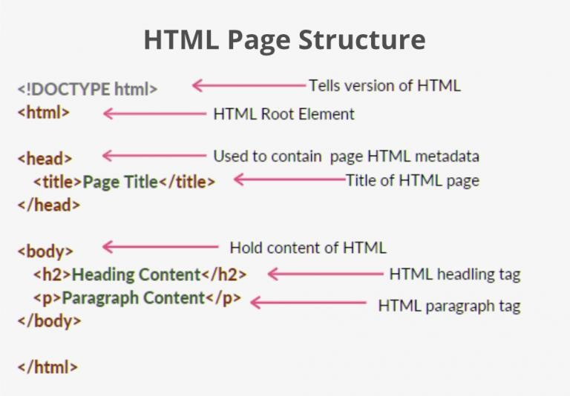

* [**<!DOCTYPE html>**](https://www.geeksforgeeks.org/html-doctypes/)– This is the document type declaration (not technically a tag). It declares a document as being an HTML document. The doctype declaration is not case-sensitive.
* [**<html>**](https://www.geeksforgeeks.org/html-html-tag/)– This is called the HTML root element. All other elements are contained within it.
* [**<head>**](https://www.geeksforgeeks.org/html-head-tag/)– The head tag contains the “behind the scenes” elements for a webpage. Elements within the head aren’t visible on the front end of a webpage. HTML elements used inside the <head> element include:
* [**<style>**](https://www.geeksforgeeks.org/html-style-tag/)– This HTML tag allows us to insert styling into our web pages and make them appealing to look at with the help of CSS.
* [**<title>**](https://www.geeksforgeeks.org/html-title-tag/)– The title is what is displayed on the top of your browser when you visit a website and contains the title of the webpage that you are viewing.
* [**<base>**](https://www.geeksforgeeks.org/html-base-tag/)– It specifies the base URL for all relative URL’s in a document.
* [**<noscript>**](https://www.geeksforgeeks.org/html-noscript-tag/)– Defines a section of HTML that is inserted when the scripting has been turned off in the user’s browser.
* [**<script>**](https://www.geeksforgeeks.org/html-script-tag/)– This tag is used to add functionality to the website with the help of JavaScript.
* [**<meta>**](https://www.geeksforgeeks.org/html-meta-tag/)– This tag encloses the metadata of the website that must be loaded every time the website is visited. For eg:- the metadata charset allows you to use the standard UTF-8 encoding on your website. This in turn allows the users to view your webpage in the language of their choice. It is a self- closing tag.
* [**<link>**](https://www.geeksforgeeks.org/html-link-tag/)– The ‘link’ tag is used to tie together HTML, CSS, and JavaScript. It is self-closing.
* [**<body>**](https://www.geeksforgeeks.org/html-body-tag/)– The body tag is used to enclose all the visible content of a webpage. In other words, the body content is what the browser will show on the front end.

***Example:***

This example illustrates the basic structure of HTML code.

<!DOCTYPE html>

<html>

<head>

<meta charset="UTF-8">

<meta name="viewport"

content="width=device-width, initial-scale=1.0">

<!--The above meta characteristics make a website compatible with different devices. -->

<title>Demo Web Page</title>

</head>

<body>

<h1>Web development</h1>

<p>welcome HTML!</p>

</body>

</html> Output:

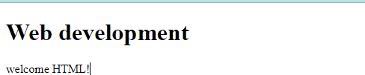

**HTML editors:**

**HTML editors** are used to create and modify HTML code. We have curated a **list of the best HTML editors** widely used by web developers and designers to create visually appealing web pages and applications.

1. Notepad

Notepad is a simple text editor that is also used to write HTML code. It is an inbuilt desktop application available in Windows OS.

### Steps to Write HTML Code in Text Editor:

**Step 1:** Open any of the text editors of your choice. Here we are using the **Notepad** text editor.

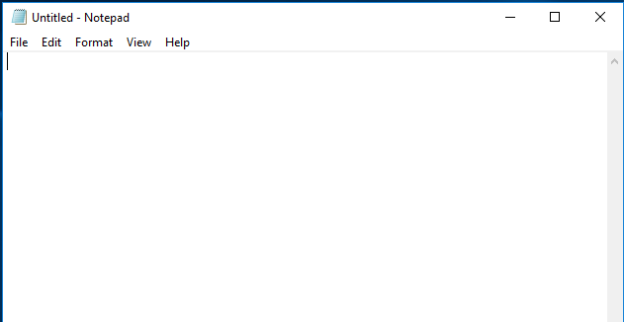

**Step 2:** Create new file: File->New File or Ctrl+N.

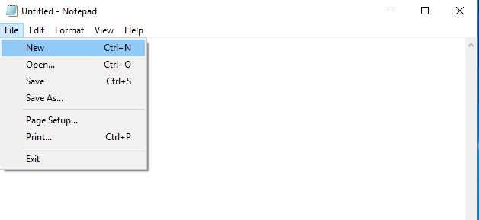

**Step 3:** Write HTML code in text editor.

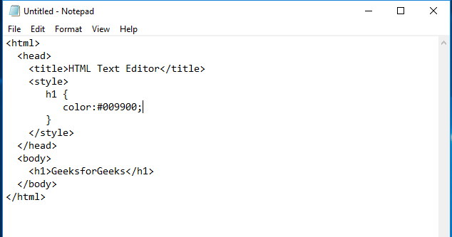

**Step 4:** Save the file with a suitable name of your choice and a **.html** extension.

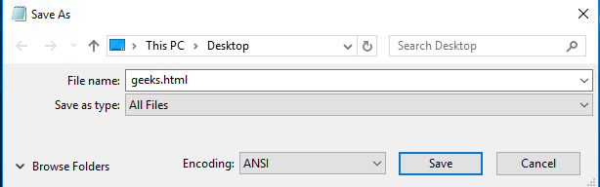

**Step 5:** Open the saved HTML file in your favorite browser (double-click on the file, or right-click – and choose “Open with”).

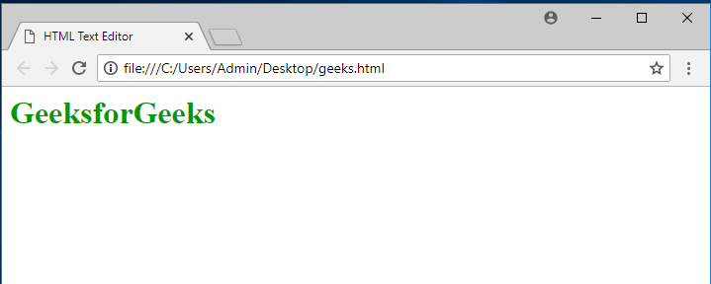

1. Visual Studio Code

It is one of the most popular code editors of today’s generation. Many companies and Software developers prefer this online HTML code editor.

**Step 1:** Open the VS code Editor and Install the Live Server. By clicking the extension button simply search live server on the search bar and download. Live server extension helps to run the code and display output.

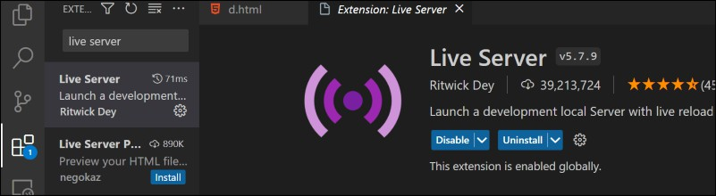

**Step 2:** Create a new File and save it with the .html extension and use the open live server button to click the right button.

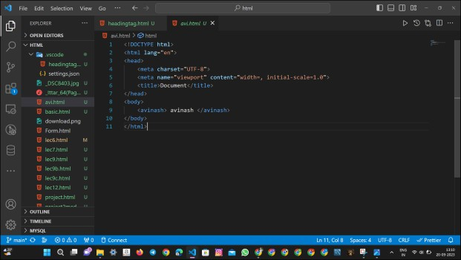

*vs code*

Reasons to use an HTML Editor:

**Editors for HTML** offer several advantages to writing and editing HTML codes. Some benefits of using HTML editors are:

1. **Syntax Highlighting**: HTML editors use color-coding to distinguish tags, attributes, and content, making code more readable.
2. **Autocompletion**: These editors suggest tags and correct common errors, improving coding speed.
3. **Code Validation**: Built-in validators check for syntax issues and missing tags.
4. **Debugging Tools**: Some editors offer debugging features to identify and fix errors.
5. **Customization Options**: Customize the interface and settings to enhance your coding experience.